3FastGenoTM genotyping Kit manual

**Highlights of 3FastGenoTM genotyping Kit**

* One buffer DNA extraction in 10 minutes in one tube;
* Direct gel-loading
* No need Ethidium Bromide staining.

**Product description**

3FastGenoTM Genotyping Kit is developed with a novel technique (patent is Pending). One buffer genomic DNA extraction makes one-step genomic DNA extraction become true. One buffer genomic DNA extraction eliminates long time digestion, expensive purification or extra neutralization steps. The genomic DNA extracted with one buffer technique can be used directly for PCR reactions. The high sensitivity and high specificity hot-start Taq polymerase in the kit has optimized for the PCR with the genomic DNA extracted by one buffer technique. The specially formulated 2X PCR master mix enables customer direct loading PCR product on agarose gel or run realtime PCR to determine genotype. The SYBR Green in 2X PCR master mix will stain the amplified DNA during PCR and the SYBR Green stained PCR product can be seen under UV or blue light, so do not need EB staining any more.

3FastGenoTM Genotyping Kit is a fast, easy, reliable kit for endpoint PCR genotyping or real-time PCR genotyping with tail snips and ear punches. The kit contains all components for PCR genotyping (except primers, template and PCR grade H2O). The simplified method greatly decreased hand on times and the chance of cross contamination between samples.

**DNA Extraction Protocol**

1. Place 2 mm tail snip, or 2 mm ear punch biopsy, or toe clipping in PCR strip tube
2. Add 50 μl of DNA extraction buffer into tubes and cap the strip tubes
3. Heat to 95°C for 20 min in PCR thermal cycler then cool down to 4°C
4. The supernatant now is ready for PCR reaction. Don’t worry about undigested tissues

* **Useful Tips:**

1. DNA is suitable for PCR reaction. Excess sample may inhibit PCR.

2. Heating for longer than 30 min does not increase the yield of DNA.

3. DNA yield is similar for tail snips, ear punches and toe clipping.

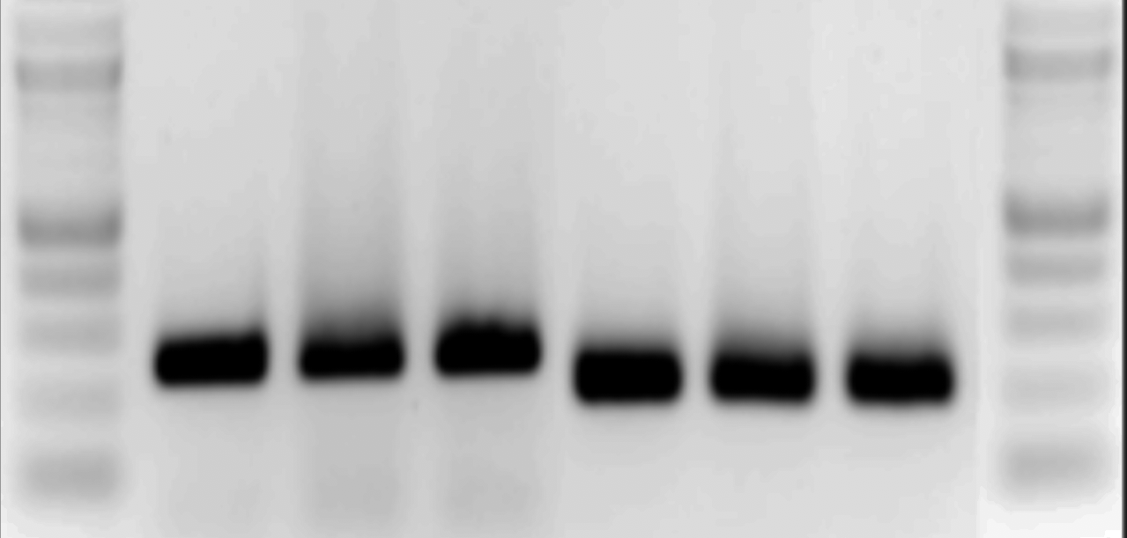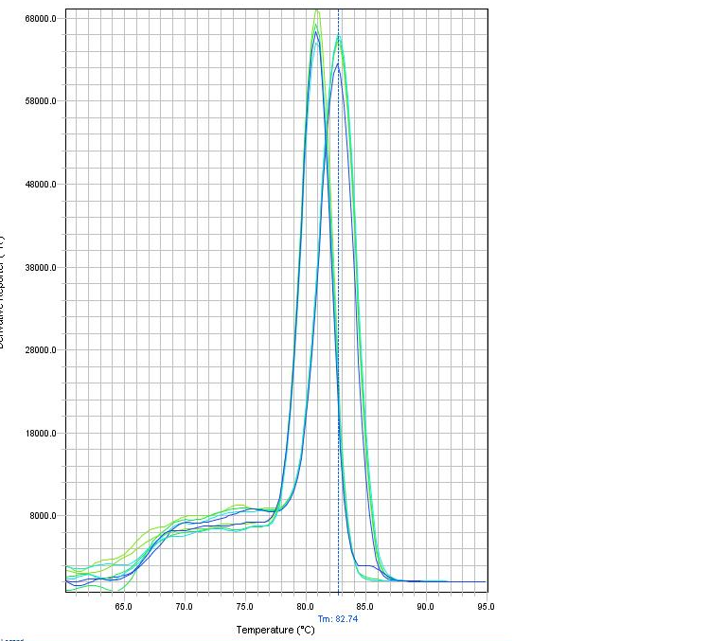

Genotyping result with one buffer extracted DNA samples from mouse-tail snips. Left, PCR products in agarose gel. Right, real-time PCR melting temperature.

**PCR amplification Protocol**

**Set up PCR reaction**

2X PCR master mix 10 µl

Primer pair mix 1 µl

ddH2O 8 µl

Extracted DNA 1 µl

_____________________________________________________

Total 20 µl

**Thermocycle of PCR reaction**

* 1. Initial step: 95 ⁰C 10 min
  2. Cycling step: 95 ⁰C for 15 sec, 55-65 ⁰C for 60 sec for 40 cycles
  3. 72 ⁰C 5 min
  4. 4 ⁰C hold
* **Useful Tips:**
* The annealing temperature in this PCR protocol may be modified dependent on customer’s specific primer and target sequence.

**Gel running and imaging:**

1. Load 5-10 µl DNA ladder or 5-15 µl PCR product to gel wells.
2. Run gel at 10-20 V/cm for 15-45 minutes.
3. Take picture under UV light in your imaging system.

* **Useful Tips:**

1. No additional loading buffer needed.
2. No Ethidium Bromide staining needed.
3. Alternatively, customer can use the melting temperature in realtime PCR to determine the genotype instead of run agarose gel.

**Kit component**

DE DNA extraction buffer

GenoPCRTM 2X PCR master mix

Prestained 100 bp DNA ladder*

|  |  |  |  |
| --- | --- | --- | --- |
| Cat # | Kit size | DE Buffer | 2X PCR master mix |
| GP200020 | 20 X | 1 ml | 200 ul |
| GP200100 | 100X | 5 ml | 1000 ul |
| GP200200 | 200X | 10 ml | 2000 ul |
| GP200500 | 500X | 20 ml | 5000 ul |

**Product Storage Condition**:

2X PCR master mix at -20 0C, DE buffer at room temperature in dark.

Shipping Condition: Blue Ice or Dry Ice

**Technical Support and order Information**

For more information about Harborgen products and to download manuals in PDF format, please visit our web site:

http://www.Harborgen.com

For additional information or technical assistance, please call or email us at:

Harborgen Biotechnology

4539 Metropolitan Court,

Frederick, MD 21704

Phone: (301) 694-2999

Fax: (301) 360-3554

General Information: info@harborgen.com

Technical Support: tech@harborgen.com

Ordering Information: [orders@harborgen.com](mailto:orders@systembio.com)